DOVER ATHLETIC SUPPORTERS’ CLUB
DASC WEBSITE www.dafcsc.co.uk EMAIL sc.dafc@gmail.com

All at DASC Committee wish our members and all fellow supporters a Merry Christmas & Happy 2024 (on and off the pitch!).

NEWSLETTER NO.3 SEASON 2023/24
DECEMBER 2023

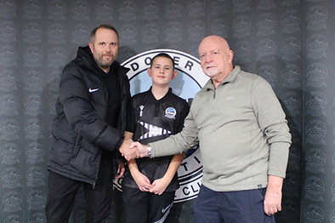

Welcome to our 3rd Newsletter of the season. The Supporters' Club are pleased to confirm our sponsorship of the Under 13's with the supply of their new training tops. Our Secretary Derek Stroud (right) with Colin Wilkins and the under 13's captain Harry Wilkins are pictured above.
Dover’s Dismal Run Continues..........

SEASON P W D L F A GD PTS POS
2022-23 20 7 6 7 27 27 0 27 12th
2023-24 20 1 9 10 19 36 -17 12 22nd

Our poor form unfortunately continues with that long awaited home win still elusive. Most of you will know by now that we have recently seen the departure of Mitch Brundle as our Manager and we at the Supporters Club wish him well in his future ventures. This departure has resulted in the appointment of a familiar face as his successor, which is Jake Leberl, with his assistant being Mike Sandmann. We wish them both every success in what we all know will be a very difficult task in getting us out of the relegation zone. COYW

The Community Trust
The committee are very aware of the precarious position both on and off the pitch and have been working very hard to support the Club, sometimes directly with Jim Parmenter, but mostly through Vikki Pawley and the Community Trust.
In addition to the generous £1,900 donation for the purchase of Wyscout and the sponsorship of the U13’s training tops we’ve recently helped the Club’s Community Day in October by helping to fill approx. 1,000 goody bags and providing some of the contents.

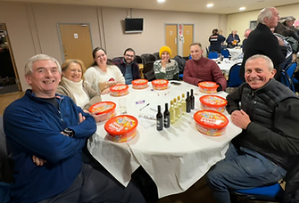
At the beginning of December we also hosted a very successful joint Christmas Quiz night in association with the Community Trust at the Centre Spot.
Thirteen teams took part and raised £261 for the new Sensory Room Project at Crabble. The winning team, Quiz Tingle Orange, is pictured left.
Look out for our next Quiz on 1st March2024

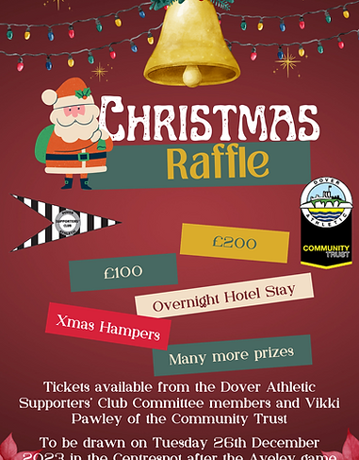
This year we are running a joint Christmas raffle with the Community Trust with a 1st Prize of £200, 2nd Prize £100, 3rd Prize Hotel Stay for 2. There are loads more great prizes (including 4 x match day VIP tickets and numerous hampers) so please keep an eye on the DAFC and DASC websites for updates.
Tickets cost £1 and are available from any Committee member, Vikki Pawley of the Community Trust and from the bar at the Centre Spot.
The draw will be made in the Centre Spot on Boxing Day after the Aveley game.
Please support this raffle by buying and selling tickets

Follow Whites Away
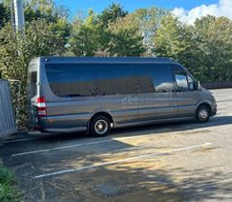
We have struggled to run coaches to away games this season, managing to cover just 3 of our 11 matches so far. We will always endeavour to run coaches to our away games but that very much depends on numbers. Recently we have experienced a growing number of late cancellations resulting in losses that we can ill afford. We understand that unforeseen circumstances can arise, however, we must advise that as from and including the next coach (Aveley), any traveller that cancels a booking after the booking deadline, (or fails to turn up on the day without having paid in advance), will be asked to pay full price up front for any future bookings. We apologise that we have had to introduce this policy but trust you all understand that we cannot continue to make losses owing to late cancellations etc. This will go some way to ensure the sustainability of our operations.
This season we have the option of a 16 seat luxury mini coach (pictured on previous page) which should give us the opportunity to cover more games. Fans that have already travelled on the coach have been very complimentary.

Coach to Aveley- Saturday 30thDecember 2023
This coach (38 seater) is definitely running and leaves Crabble at 12.00pm and costs £27 for members, £32 for non-members, £14 for Accompanied (U16) and Youth Members (U18), £19 for Youth non-members
BOOK BY SUNDAY 24TH DECEMBER TO ENSURE YOUR SEAT
You can book all away coaches by calling/texting Craig on 07934 300335, emailing dasccoaches@gmail.com or seeing us in the Centre Spot at home games.

Pitch Squares
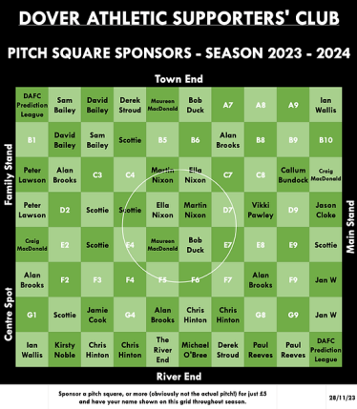
Please help us raise £850 towards the upkeep of the Crabble pitch

We’re well over half way with 48/80 sold so far. There is still time to achieve our goal (no pun intended) which is to raise £850.
Selling all the squares would raise £400. This would be matched by the Supporters Club plus £50 for selling them all.

Race Night
Our latest race night was held on Saturday 27th October and was kindly hosted and sponsored by The Cricketers Pub. It once again proved to be a successful night with all those attending enjoying the atmosphere with some actually going home with a profit!! We would encourage more members to support these nights as they make much needed funds for us and without them we would not be able to support local initiatives for both the Community and the Football Club.

Neil Le Bihan

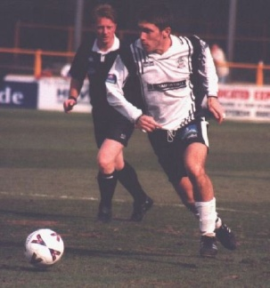
It is with great sadness that we have to report the passing of Neil Le Bihan. Neil was arguably part of our best midfield in season 1999/2000. He made 171 (+12) competitive appearances and scored 18 goals across 5 seasons (1997-2002) for us. Sadly Neil took his own life after a challenging period of mental health, something he had been fighting for a while. If anyone reading this is struggling then please reach out to someone, or if anyone knows of someone struggling then please offer help.
The Samaritans are available 24/7 and are there to listen.
Fixture Update

Tues 26-Dec-23 NLS Aveley H 3pm
Sat 30-Dec-23 NLS Aveley A 3pm
Sat 06-Jan-24 NLS Truro City H 3pm
Sat 13-Jan-24 NLS Taunton Town A 3pm
Sat 20-Jan-24 NLS Torquay United A 3pm
Tues 23-Jan-24 NLS Tonbridge Angels H 7.45pm
Sat 27-Jan-24 NLS Slough Town H 3pm
Sat 03-Feb-24 NLS Braintree Town A 3pm
Sat 10-Feb-24 NLS Worthing A 3pm
Sat 17-Feb-24 NLS Dartford H 3pm
Tues 20-Feb-24 NLS St Albans City H 7.45pm
Sat 24-Feb-24 NLS Chippenham Town A 3pm
Sat 02-Mar-24 NLS Maidstone United H 3pm
Sat 09-Mar-24 NLS Weston Super Mare A 3pm
Tues 12-Mar-24 NLS Eastbourne Borough A 7.45pm
Sat 16-Mar-24 NLS Havant & Waterlooville H 3pm
Sat 23-Mar-24 NLS Farnborough Town H 3pm
Fri 29-Mar-24 NLS Welling United A 3pm
Mon 01-Apr-24 NLS Chelmsford H 3pm
Sat 06-Apr-24 NLS Hemel Hempstead Town A 3pm
Sat 13-Apr-24 NLS Hampton & Richmond A 3pm
Sat 20-Apr-24 NLS Yeovil Town H 3pm

KSC Beckenham Town (A) TBA, NLS Truro City (A) TBA.

Your Current Committee

The current Committee is: Lee Sansum (Chair), Derek Stroud (Secretary), Paul Reeves (Treasurer), Craig MacDonald (Membership Secretary) Kirsty Noble (Social Media/Community Officer), Mike Wood (Deputy Chair), Richard Reynolds (Club Liaison Officer) and Gez Noble

If you wish to contact us or send any ideas/suggestions/items of interest you may have, please let one of the Committee members know or email us at sc.dafc@gmail.com.

Please also use the same methods of contact to let us know if you are interested in joining our Committee, new members with fresh input are always welcome.

COYW

