DOVER ATHLETIC SUPPORTERS’ CLUB

DASC WEBSITE www.dafcsc.co.uk EMAIL sc.dafc@gmail.com

NEWSLETTER NO.4 SEASON 2023/24
APRIL 2024

Welcome to our 4th and final Newsletter of the season.
Relegation is Confirmed, Our End of Season Awards and the Dover Manager Joins our April Committee Meeting

A Heartfelt Message from the Manager.............................

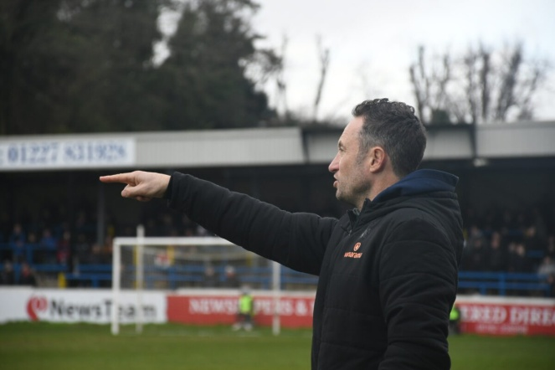
“Let’s make no bones about it; it’s been an extremely tough season for us all.
Relegation from National League South hurts each and every one of us.
There’s no doubt that we’ve gone through one of the hardest periods our club has ever had.
Now it’s time to regroup, rebuild and start putting together a community club we should all be immensely proud of.
It won’t be easy, but we’re stronger together and that’s during the good times and the bad.
I’d like to say a huge thank you to all of our supporters; an overwhelmingly passionate group, particularly those who travel both home and away.
I can assure you all that your unwavering support has not gone unnoticed.
Neither has your patience, belief and understanding, and for that I thank you.
I take great pride in leading this great club; it’s a responsibility that I shoulder with passion and a desire to make sure we all have a club to be proud of.
Look after yourselves and each other over summer and I look forward to seeing you all next season.”

Jake

Relegation Finally Confirmed at Welling
“April is the cruelest month” so wrote TS Eliot whilst at Margate in 1921. The epic poem certainly wasn’t about the lot of the football supporter but it could have been. April is the month when supporters of struggling clubs begin to worry if their team is good enough to avoid the drop. In the NLS it was April that one team suddenly and unexpectedly got sucked into a relegation battle and didn’t survive (Dartford). It was also the month that another team had so many games in hand and didn’t win enough to escape the drop (Taunton). Then there was Dover and Havant & Waterlooville who had been rooted to the bottom of the table for most of the season and weren’t expected to survive. However, it wasn’t until early April at Welling that relegation was eventually confirmed after 15 years in the National League. Even the 48 points that saved us last season would not have been enough this year! Bring on Hashtag United!

NLS Champions Yeovil Town
Play Offs
Relegated Taunton, Dartford, Havant & Waterlooville, Dover

End of Season Awards
The popular DASC annual ‘End of Season Awards’ were held in the Centrespot immediately after the Yeovil game and was hosted by our Chairman Lee Sansum.

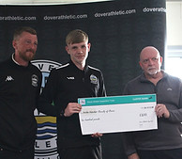
We started off by awarding a £100 donation to Archie Hatcher who was raising money for the NSPCC by running in the London Marathon the following day. On Sunday and wearing number 57887 Archie finished in o/a position 14,081 completing the 26.2 mile course in a respectable time of 03:42:49. Well done Archie.
You can donate by clicking here or by going to the following website https://www.justgiving.com/page/archie-hatcher-1692809478599.

We then awarded a £100 donation to Nick Dembele who is raising money for Cancer Research UK by doing a push-ups challenge.
You can donate by clicking here or by going to the following website https://fundraise.cancerresearchuk.org/page/nicks-giving-page-1583.

Winner of the Golden Boot was Zidane Sutherland.
He wasn’t present to collect his trophy. You can see all his goals on our website by clicking www.dafcsc.co.uk

The Andy Fisher Memorial Trophy for the Away Player of the Season was won by George Nikaj. The trophy and shield were presented to George by Donna Fisher.

Due to falsified voting slips we had to null and void the vote for the Player of the Season award and we asked Jake to nominate his player of the season. The Simon Harris Memorial Trophy for the Overall Player of the Season was presented to John Oyenuga by Kevin Harris. A £100 donation has been made to his chosen charity which is the Anchor of Hope Church.

A free buffet was provided by the Supporters Club. We would like to thank both Donna Fisher and Kevin Harris for attending and presenting the awards. The shields are once again on display in the Centre Spot. There are more photos on our website www.dafcsc.co.uk

Dover Manager Joins our April Committee Meeting
Jake Leberl and George Cory joined our April committee meeting to talk about the club and ways DASC could work alongside by helping him and the football club. The main points were:
- Very passionate and committed to Dover.
- Not able to use Wyscout in Isthmian league.
- Would like us to help/sponsor pre-season friendly with Calais. Not possible this year due to coach booking and international clearance.
- Would like us to promote 200 club to get it up and running (see item below).
- Doesn’t know how many players, if any, will re-sign.
- Confident can get a competitive team together for next season. Biggest barrier to signing players is their agents, even at this level. First question agents ask is the “release” clause!
- Considering how tight money was last season still had to find money for over 80 players’ shirts (H&A) with names on the back which cost a small fortune.
- No names on shirts next season.
- Thanked us for the purchase of the jump boxes, they had a profound impact on players’ fitness

200 Club
For just £10 a month, you could be in with a chance of winning £1000 each month in Dover Athletic FC’s new 200 club draw. To register your interest, please send your name and phone number to sc.dafc@gmail.com this is to become a vital source of fundraising for the football club and is a way for you all to help with that whilst also giving you a chance of winning £1000!
Dover Athletic Supporters Club
We have felt compelled to write this article following many negative comments made about the Supporters Club recently, some of them emanating from DAFC. It has long been a misconception that the Supporters Club just organizes coaches for away travel; however this is just one of the things that we successfully do and have done for many seasons.
​
It’s our members and their efforts throughout the season that allow us to continue to support the football club and local community in many ways. So where has this money gone this season:-

At the start of the season we made a substantial investment of £1,900 to purchase the Wyscout system, which allowed the management team to obtain footage of opponents from teams across our division. This was planned to be an annual commitment, however due to our relegation this season and this system not being present in the Isthmian League we will now look to re-invest this money elsewhere.
​
We also decided to support the future of Dover Athletic and sponsored the Under 13’s during their 23/24 season. When we found out that Jake was working on individuals fitness and offering players extra PT sessions outside of the scheduled training, we purchased a set of jump boxes to help make these sessions as impactful as possible. We have made £100 charitable donations to the NSPCC (Archie Hatcher London marathon) Cancer Research UK (Nick Dembele push up challenge) Anchor of Hope Church (player of the season John Oyenuga’s chosen charity). We have also donated £200 locally to the Dover Gymnastics Club as they look to lay new flooring and are currently raising the funds to do so (presentation photo to follow).

We once again ran the pitch square scheme, matching the total income received, which raises money to aid the maintenance of the pitch something we will look to run again next season.
We ran multiple quiz and race nights throughout the year with one quiz being a joint effort with the Community Trust which proved to be a great success as did the joint raffle that was hosted with them for Christmas. All monies raised from the quizzes were donated to the football club directly.
​
A special mention to one of our members: Mark Winter, who went out of his way to run a meat raffle in the town. Due to the success of this raffle we offered Mark the opportunity to run this under our license so it remained in line with the Small Lotteries Licensing Regulations and we are pleased to say that his efforts have raised in the region of £6,000 in the past year for the football club. Great effort Mark and do keep up the good work.
​
Again, none of this is ever possible without your support and your membership means more to us than we can say in just one message. So if you’re reading this and you are not yet a member of the supporters club, why not get in contact today by emailing membershipdasc1@gmail.com to register your interest and join us in pushing the club forward into a positive season ahead. Despite whatever happens on and off the pitch DASC will still be here supporting the club financially and practically.

Coach Travel
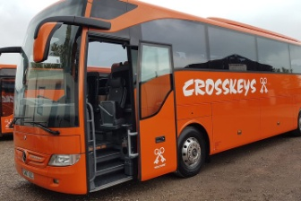
Regular coach travelers will know that it’s been a struggle to get bums on seats this season. This is understandable when you consider the team’s performance, the cost of coach hire and the distance of some away games; seven with + 400 mile round trips. However, we did manage to run seven coaches and return a small profit.
Our coaches to Hemel Hempstead and Hampton & Richmond were subsidised by Megger, the football club’s main sponsor, enabling us to offer a flat rate fare of £10.00 for all. 76 fans took up the offer with 32 going to Hemel and 44 going to Hampton. A very big thank you to Megger for their generous donation.

Pitch Squares Raises £530

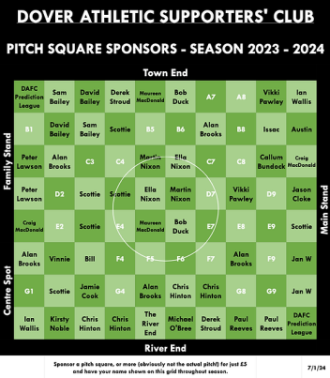
Sale of the Pitch Squares for the 23/24 season has now finished. We sold 53 squares raising £265.00. This will be matched by the Supporters Club making a total of £530.00 to go towards the maintenance of the Crabble pitch.

A big thank you to all those that purchased pitch squares this season. Those that didn’t also missed the opportunity of having their name in the match day programme.

British Heart Foundation Football Fan Campaign 2024
We have received a communication from a body known as the Raw Research Casting Team; they are working on a campaign for the British Heart Foundation to raise awareness that 12 young people lose their lives per week due to sudden cardiac death in the UK. They are looking to families of young people (aged 35 and under) who lost their lives due to this in the last 20 years and who are also football fans. If you have been affected and wish to find out more, then details on this can be found on our website www.dafcsc.co.uk

Your Current Committee
Since our last Newsletter we have lost one committee member and gained one new one. Gez Noble decided to step down in March after many years on the committee. We thank him for all his hard work and input and wish him well. Our new member is Vikki Pawley who some of you will know works for DAFC Community Trust.

The current Committee is: Lee Sansum (Chair), Mike Wood (Vice Chair), Derek Stroud (Sec), Paul Reeves (Treas), Craig MacDonald (Memb Sec) Kirsty Noble (Soc Media/Community Officer), Richard Reynolds (Club Liaison Officer), Vikki Pawley (Committee)

We do have vacancies on the Committee so please consider putting yourself forward; it involves attending one meeting a month that’s all! Your contribution could be invaluable to our current Committee members.
COYW

