DOVER ATHLETIC SUPPORTERS’ CLUB
DASC WEBSITE www.dafcsc.co.uk EMAIL sc.dafc@gmail.com
NEWSLETTER NO.2 SEASON 2025/26
January 2026
Welcome to our 2nd Newsletter of the Season.
Details of our remaining fixtures & upcoming events
Richard and the Management Team thank the Supporters Club for the Purchase of Wyscout


Events
Our next Quiz Night will be a joint event with the Community Trust on the 6th March, 7:30 for 8pm start in the Centre Spot.
Entry will be £4.00 per person with a maximum of 8 on a team. To enter a team, please email sc.dafc@gmail.com or speak to a committee member.

Our Christmas Raffle proved to be a great success, raising £963, which was shared 50/50 with the Community Trust. A big thank you goes to everyone who donated prizes or bought tickets.
A list of winners can be seen on our website.

It’s fast approaching the business end of the season, which means that it’s time to start thinking about the End of Season Awards. The awards will take place after our home game against Chesham United on Saturday 25th April. Towards the end of the season, we will provide information on how you can vote for your chosen player of the season.

A reminder for our members who travel to away games - if you don’t travel on our coaches, you can still vote for your Man of the Match.
Please email your vote to sc.dafc@gmail.com within 24 hrs of the game, quoting your name and membership number.

AGM
It’s that time of the year again! Our Annual General Meeting will be held in the Centre Spot on Saturday 21st February at 2pm before the Weston-super-Mare game. Full details are enclosed with this newsletter. Please attend if possible.

Coaches
Saturday 24th January - coach to AFC Totton leaves Crabble at 10:15am and is £40 members, £45 non-members, £25 youth members, £30 youth non-members and £25 accompanied under 16’s.
Booking deadline extended - 9am on Saturday 24th January
Match Tickets for this game (Adults £15, Concessions (65+) £11 and Child (5-17) £6) are now on sale from Totton’s website https://afctotton.ticketco.events/uk/en/e/afc_totton_v_dover_athletic

Saturday 31st January - coach to Hemel Hempstead Town leaves Crabble at 11:15am and is £30 members, £35 non-members, £20 youth members, £25 youth non-members and £20 accompanied under 16’s.
Booking deadline - 6pm on Sunday 25th January

Tuesday 10th February - coach to Dorking Wanderers leaves Crabble at 4:45pm and is £25 members, £30 non-members, £15 youth members, £20 youth non-members and £15 accompanied under 16’s.
Booking deadline - 4pm on Wednesday 4th February

Saturday 14th February - coach to Enfield Town leaves Crabble at 11:30am and is £30 members, £35 non-members, £20 youth members, £25 youth non-members and £20 accompanied under 16’s.
Booking deadline - 4pm on Wednesday 4th February

Anyone who travels on the coach to Dorking on 10th February will be eligible for a £5 reduction on the cost of the Enfield coach on 14th February.

Match tickets for AFC Totton are £2 cheaper when purchased in advance.

To book on any of the upcoming coaches call or text 07934 300335 or email dasccoached@gmail.com.

Wyscout
Some of you may remember that we purchased Wyscout for the Management Team at the start of the season. We spoke to the club's scout, Richard and asked him to tell our members how this purchase has helped them so far this season.

“We have benefited hugely from Wyscout and are incredibly grateful to the Dover Athletic Supporters Club for ensuring we have the platform at our disposal this season! The National League South now contains eight or nine teams operating on a full-time basis with even more moving towards a hybrid training model. In contrast, we have minimal contact time with the players, particularly if we have a midweek match. Therefore, we need to be shrewd with how we best utilise those few hours we do get to try and bridge the gap. Prior to each match, we produce a short video edit of our upcoming opponents which the players are supplied with two days in advance. This focuses on their strengths, weaknesses, set pieces and general approach in and out of possession. We also run through this collectively at training on a Thursday and in pre-match meetings to reaffirm how we are going to deploy our gameplan. One of the other major benefits of having Wyscout is the ability to review our own games and gain access to high-level data. We typically deliver a post-match review to the players prior to training on a Tuesday. This allows us the opportunity to run through our analysis and reinforce the positive aspects of our performances - as well as identifying areas for improvement and how we may address this. Players are also given access to our match footage, uploaded to Hudl via Wyscout, within 24 hours of the full-time whistle. In addition, they are able to request individual clips and statistics from management if they want to delve deeper. Wyscout is an essential tool for this level of football and effectively acts as an extension of the management team - also helping to inform decisions we make around player recruitment. We spend large chunks of the week, outside of our day jobs, on the platform and it is even more crucial with such a small staff team. We would like to say a huge thank you to the Supporters Club for making this possible with your generous donation in the summer!”
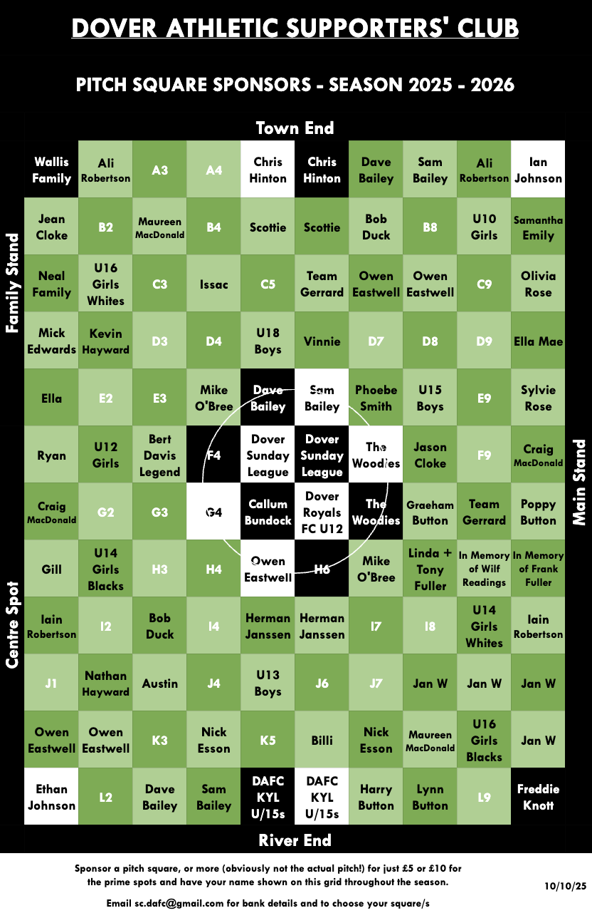
Pitch Squares
This season's pitch squares are still available for purchase and cost £5 each or £10 for the prime spots (black or white).

There are currently 36 available squares to purchase, with proceeds raising money for Dover Athletic FC. Email sc.dafc@gmail.com or see a Committee Member in the Centre Spot to purchase yours.

A quick reminder that if all squares are sold, those who bought one will automatically be entered into a raffle with a cash prize of £25. The draw will be made at the end of the season awards.

Fixture Update
Details of our remaining fixtures are shown below and may be subject to change.
Saturday | 24th January | A | AFC Totton | 3pm
Saturday | 31st January | A | Hemel Hempstead Town | 3pm
Tuesday | 3rd February | H | Torquay United | 7:45pm
Saturday | 7th February | H | Worthing | 3pm
Tuesday | 10th February | A | Dorking Wanderers | 7:45pm
Saturday | 14th February | A | Enfield Town | 3pm
Saturday | 21st February | H | Weston-super-Mare | 3pm
Tuesday | 24th February | H | Hornchurch | 7:45pm
Saturday | 28th February | A | Slough Town | 3pm
Saturday | 7th March | A | Hampton & Richmond Borough | 3pm
Tuesday | 10th March | H | Tonbridge Angels | 7:45pm
Saturday | 14th March | H | Chippenham Town | 3pm
Saturday | 21st March | A | Chemlsford City | 3pm
Saturday | 28th March | A | Salisbury | 3pm
Friday | 3rd April | H | Maidstone United | 3pm
Monday | 6th April | A | Ebbsfleet United | 3pm
Saturday | 11th April | H | Farnborough | 3pm
Saturday | 18th April | A | Maidenhead United | 3pm
Saturday | 25th April | H | Chesham United | 12:30pm

Your Current Committee

The current Committee is: Mike Wood (Chair), Richard Reynolds (Vice Chair/Club Liaison Officer), Craig MacDonald (Membership Secretary), Kirsty Noble (Secretary/Social Media) and Bob Duck (Treasurer).

We do have vacancies on the Committee so please consider putting yourself forward; it involves attending one meeting a month, that’s all! Your contribution could be invaluable to our current Committee members. New members with fresh input are always welcome.

In addition to running the membership list and booking coaches for away games, the committee organises various fundraising events. If you can offer your support to help grow the Supporters Club, we’d love to hear from you.

COYW

