***DOVER ATHLETIC SUPPORTERS’ CLUB***

**DASC WEBSITE** **www.dafcsc.co.uk** **EMAIL sc.dafc@gmail.com**

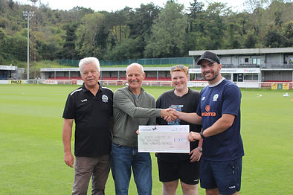

***NEWSLETTER NO.2 SEASON 2023/24***

***OCTOBER 2023***

***Welcome to our 2ndNewsletter of the new season.***

***Will a good cup run kick start our season? The Supporters Club donate £1,900 to DAFC for the purchase of Wyscout and details of our new away coach partner***

**The FA Cup**

Two months into the season and our first home win came, not in the league, but in the FA Cup against Hastings United. The 3-2 victory against the Premier Division Isthmian League side was not as close as the score-line suggests and we probably should have scored more. The prize money was handy £3,375.

In the Third Qualifying Round we played against Haringey Borough who play in the same league as Hastings. We managed a 2-1 victory despite a very disappointing first half we narrowly avoided a potential “banana skin!” We have been drawn away to Eastleigh in the Fourth Qualifying Round on Saturday 14th October, a difficult fixture but here’s hoping for a decent cup run through to the First Round Proper to kick start our season and earn much needed cash for the club. We are hoping to run a coach to this game so please let us know if you are interested? **Call/Text 07934 300335 asap.**

**The Emirates FA Cup Season 2023-24 - Prize fund**

Second Qualifying Round Winners £3,375 Losers £1,125

Third Qualifying Round Winners £5,625 Losers £1,875

Fourth Qualifying Round Winners £9,375 Losers £3,125

First Round Proper Winners £41,000

Second Round Proper Winners £67,000

Third Round Proper Winners £105,000

**“Building Bridges” with DAFC**

Over the last few months our Supporters Club Liaison Officer (Richard) has had meetings with both the Community Trust (Vikki Pawley) and Jim Parmenter to discuss ways that the Supporters Club, the Trust and the Football Club could all work together for our mutual benefit. The meetings were very positive and future meetings are planned.

One outcome was that the Supporters' Club have recently agreed to donate £1,900 to the Football Club to fund the purchase of the ***Wyscout.*** (See photo above). This piece of kit will enable DAFC to analyse the opposition's performance data as well as their own and also look at the individual performance data of potential signings. With Dover Athletic being one of the few clubs in our league that previously did not have access to this product we felt that this would be an important and intuitive tool for the club to have access to. Mitch Brundle sent the following message after receipt:

“

***Firstly, I would like to thank the Supporters Club for their kind donation in helping the football club gain a vital tool for match preparation. Despite only having it for a short period of time I think we have only lost once since, including going to table topping Bath and getting back on the bus with a point. The Wyscout platform has given me invaluable information as it clips the teams’ highlights from games and helps to get into the nuts and bolts of what we are looking for when analysing opposition. Again, I couldn't thank you enough and I think I speak on behalf of everyone when I say we really appreciate it****.*

***Brunds***

“

In a separate Community development, the Supporters Club has agreed to sponsor the DAFC under 13 Youth Team with training tops. The tops will sport the Supporters Club Logo and will be seen at Crabble on match days when the under 13’s will act as ball boys for the first team.

And finally Vikki Pawley from the re-launched DAFC Community Trust attended our August Committee Meeting to discuss ways in which the Supporters Club and the Community Trust could work with each other. She has requested to attend our October meeting to discuss an upcoming Community Day on the 21st October and a joint quiz on 1st December. Keep an eye on Social Media for further announcements.

We think you’ll agree that this is all very positive stuff. Let’s hope we can keep the momentum going.

**Our New Coach Partner**

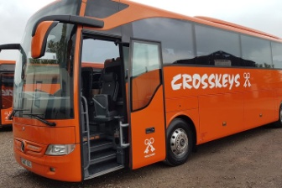We have found it very difficult to run away coaches this season due to new onerous booking conditions and steep price rises requested. Sadly, after an association lasting many years we have decided to part company with Bayliss. Crosskeys are our new coach partner and they have offered better terms and conditions, including a 16 seater coach if required. We look forward to working with them and would ask that you all try and use the coaches as much as possible to maintain a mutually beneficial working relationship between us.

**Our first coach in the league is to Chelmsford on Monday 23rd October 2023. The price for members is £32 and leaves Crabble at 16.30. To book: please call/text 07934 300335 no later than Monday 16th October.**

Crosskeys are not only a coach operator but are also ABTA travel agents and have agreed to offer a 10% discount on any of their day trips on production of a DASC membership card/number. Please support our partners and give them a try.

**Forthcoming Events**

Following the success of our September quiz at the Centre Spot which raised £247.21 towards replenishing our funds after our donation to the Football Club, we plan to hold our next one on 1st December @ the Centre Spot. The aim for this one is to be a combined Community Trust and Supporters Club Quiz and is termed as our “Christmas Quiz”. Entry will remain at £3.00 per person with a maximum of 8 on a team. To enter a team please email [sc.dafc@gmail.com](mailto:sc.dafc@gmail.com).

Our popular Race Night returns to the Cricketers on Friday 27th October starting at 7.30pm. We are looking for race sponsors for the 8 races. If you would like your company promoted on the night and on social media posts prior to the event please contact sc.dafc@gmail.com.

Race sponsorship is £25 + a donated prize for the winning owner.

To own and name a horse costs £3 and to be a Jockey is £2. Each winner receives a prize of £12 and £8 respectively, with of course the Sponsors prize going to the winning owner too.

Get involved and make it a great night raising funds! It is a fun event for all.

**New Committee Members**

****The current committee have been running DASC with the bare number of members for some time. Due to holidays, illness and work commitments (not to mention age!!) it has become apparent that this is no longer sustainable and we need at least 4 new committee members to share the load. Why not give it a try. We meet in the cricketers every 2nd Monday of the month at 7.30pm. Meetings last for 1-2 hours. If you are interested please email the Supporters Club or speak to one of our committee members in the Centrespot on match days. This is your chance to have an input into what we do and how we can improve.

**Kent F.A. Green Initiative**

We have received an email from Vikki of the Community Trust containing information about a new initiative driven by the Kent F.A. entitled ***Kent Green United***. We have been asked to seek suggestions from our members for ideas that would promote environmental responsibility, (especially on match days) in order to lead to a more sustainable future when attending matches etc.If you have any suggestionsplease email them to us.

**Pitch Squares**

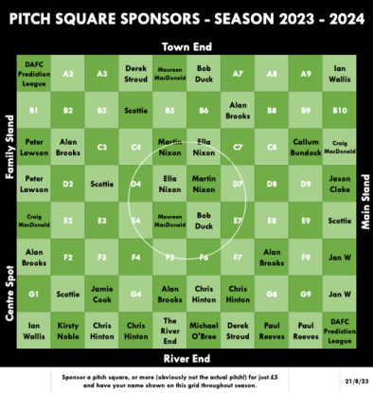We’re just over halfway with 41/80 squares sold. So far that’s raised £205 plus £205 from the Supporters Club making a total of £410. But we can do better than that. So come on guys let’s try and fill the grid. Remember the Supporters Club will match the amount of money raised plus another £50 if we can sell them all making a total of £850.

**Fixture Update**

|  |  |  |  |  |  |
| --- | --- | --- | --- | --- | --- |
| Sat | 07-Oct-23 | NLS | Taunton | H | 3pm |
| Sat | 14-Oct-23 | FAC | Eastleigh | A | 3pm |
| Sat | 21-Oct-23 | NLS | Hemel Hempstead Town | H | 3pm |
| Mon | 23-Oct-23 | NLS | Chelmsford | A | 7.45pm |
| Sat | 28-Oct-23 | NLS | Farnborough Town | A | 3pm |
| Tues  Sat | 31-Oct-23  04-Nov-23 | KSC  NLS | Beckenham Town  Hampton & Richmond | A  H | 7.45pm  3pm |
| Tues | 07-Nov-23 | NLS | Welling United | H | 7.45pm |
| Sat | 11-Nov-23 | NLS | Yeovil Town | A | 3pm |
| Tues | 14-Nov-23 | NLS | Maidstone United | A | 7.45pm |
| Sat | 18-Nov-23 | FAT | 2nd Round Proper |  |  |
| Tues | 21-Nov-23 | NLS | Eastbourne Borough | H | 7.45pm |
| Sat | 25-Nov-23 | NLS | Weston Super Mare | H | 3pm |
| Sat | 02-Dec-23 | NLS | Havant & Waterlooville | A | 3pm |
| Sat | 09-Dec-23 | FAT | 3rd Round Proper |  |  |
| Sat | 16-Dec-23 | NLS | Bath City | H | 3pm |
| Sat | 23-Dec-23 | NLS | Weymouth | A | 3pm |
| Tues | 26-Dec-23 | NLS | Aveley | H | 3pm |
| Sat | 30-Dec-23 | NLS | Aveley | A | 3pm |
|  |  |  |  |  |  |

**Key Dates**

Isuzu FA Trophy 2nd Round Proper – Draw Monday 20th Nov 2023 – Winners get £3750 and losers get £1000

• Last NLS Match Day – Saturday 20 April 2024  
• Play-Off Eliminator A (5th v 6th) – Tuesday 23 April 2024  
• Play-Eliminator B (4th v 7th) – Wednesday 24 April 2024  
• Play-Off Semi-Finals – Sunday 28 April 2024  
• National League North/South Promotion Finals – Sunday 5 May

**And Finally July Newsletters’ Deliberate Mistake!**

Some of the eagle eyed amongst you spotted the mistake in July’s issue where we got our W’s mixed up and confused Weymouth with Worthing. We would like to blame predictive text for the error but the truth of the matter is that the euphoria of staying up and too many sherbets got the better of us!!

**Your Current Committee**

The current Committee is: Lee Sansum (Chair), Derek Stroud (Secretary), Paul Reeves (Treasurer), Craig MacDonald (Membership Secretary) Kirsty Noble (Social Media/Community Officer), Mike Wood (Deputy Chair), Richard Reynolds (Club Liaison Officer) and Gez Noble

COYW